In order to get a login please have your scheduler email Alex Park at appark@ucdavis.edu for login and password for each team.

http://davislegacysoccer.org/reservations/

Overview of the Features in Reservations

When logged in, you should see the following.
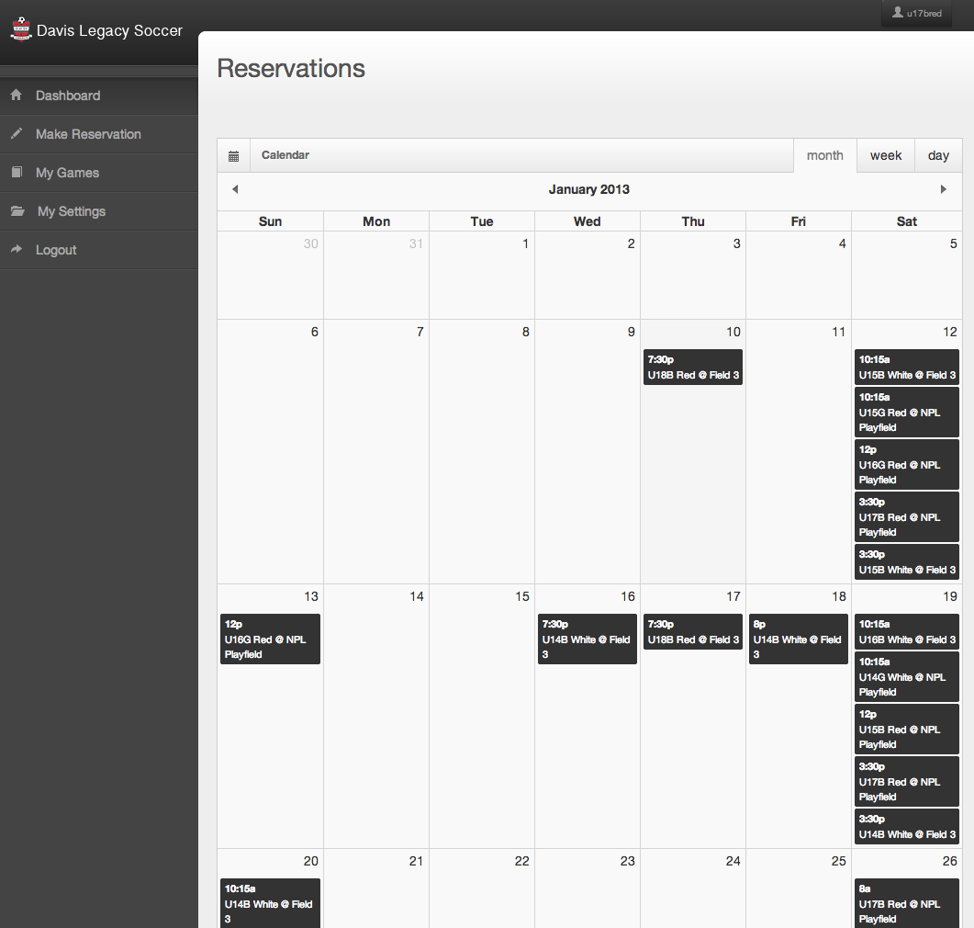

Listed here are the menu (located on the left) and the current reservations. Each of these reservations may be clicked on to find additional information (such as who made the reservation). You can also change the scale of the calendar by changing the view to show you a weekly agenda, or even a daily one by clicking on the “week” and “day” tabs on top of the calendar.

From here, first update your password to something you can remember (or you can choose to leave it the same). Simply enter in your old password and then enter in your new ones in the fields “New Password” and “Retype New Password”, afterwards, click on “Save Changes” and your password will be changed. You will be located back at the home page.

Next up, and probably the most important feature, is the “Make Reservation” tab. Here, you’ll be able to reserve a field during the times that they are available. To begin, click on the “Make Reservation” tab. You should now be seeing the following.

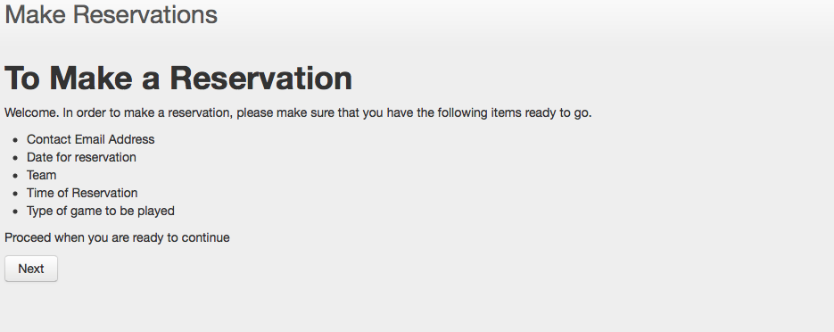
Once you have the necessary information on hand, click next and you should see the following:
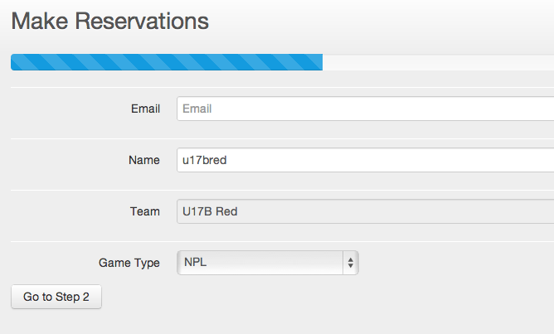

Correct information as necessary and select the ‘game type’ before proceeding.

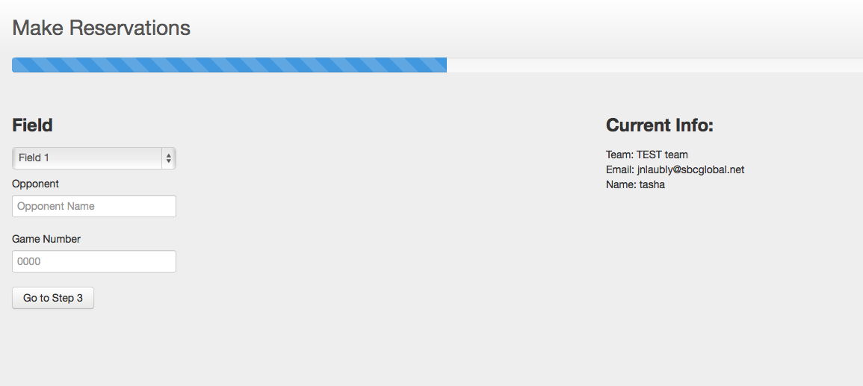

At this step, check that the info listed under “Current Info” is correct. If so, continue on by selecting a field that you wish to play on, enter your opponents name and the game number. Then proceed to step 3. The screen should now look like this.

Notice that the “Current Info” has been updated to show the field that you choose on the previous step. On this step, the most important thing is to select a date. To do so, simply click on the box below “Choice of Date” and the following calendar will appear.

From here, simply choose the date that you wish to make your reservation on, and now a list of times available on that date appear.

If one of these times works out, select it and move on. If not, simply change the date by reclicking the “Choice of Date” and choose a new date which will give you new available hours. Once you are satisfied with the date and time, move on to confirm the reservation. The screen should look like the following.

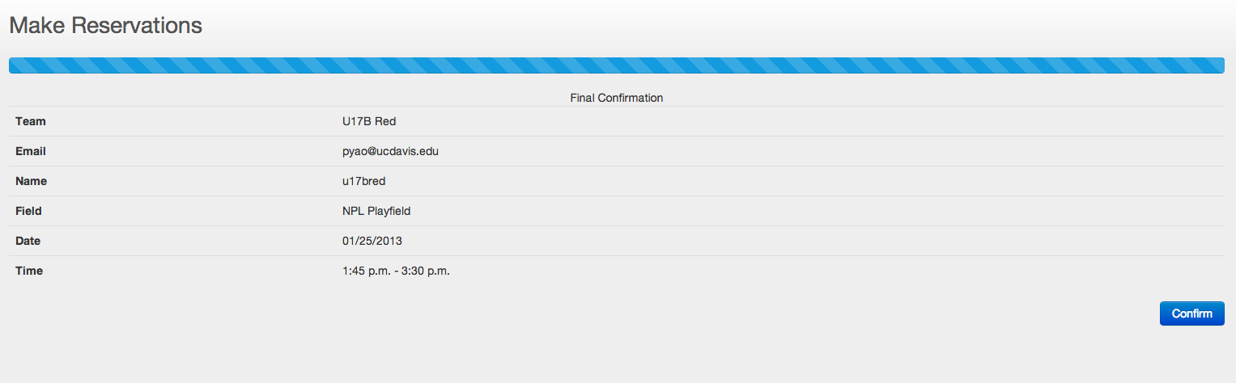

If everything on here is correct, click confirm and your reservation will be made! If not, you can choose to start back from the beginning and enter in your new choices.

Afterwards, you can check on the progress of your reservations under the “My Games” tab, located on the menu. All games listed under “My Games” will show the information for each event as well as whether the game has been approved yet. Additionally, you can cancel an event if you no longer wish to have that game.
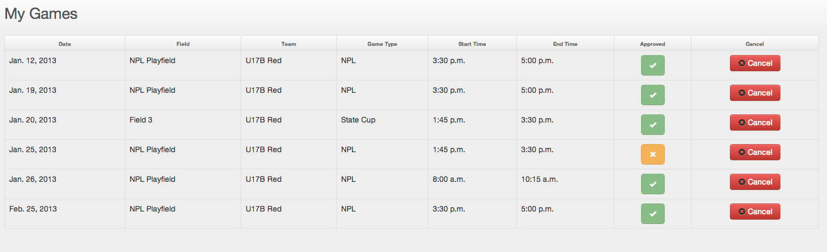

Note that upon canceling a game, you will be redirected to a form asking you to write a message of why the game was canceled. If you do not wish to write anything down, for example it could have just been a mistake, simply click “Cancel” and you will be redirected to the home page. Otherwise, just fill in the info and click “Send Mail” to send you message off.

Lastly, when you are all done, you can choose to logout of the system by clicking the “Logout” button at the bottom of the menu.

If there are any errors with the site, please send an email to appark@ucdavis.edu and I’ll get back to you as fast as possible.

